Results

To establish differences in the bacterial composition of the microcosm starting materials, we characterized the microbial communities in samples of the alfalfa soil as well as the alfalfa and compost amendments using amplicon sequencing of the 16S rRNA gene. Shown in figure 1 are the average relative abundance of the five most abundant phyla in amendments and soil used in this study. Overall, the five most abundant phyla from each amendment and soil represent at least 75% of the bacterial community in each sample from the soil and amendments. The relative abundance of the top five phyla was more even in the starting soil, while compost and alfalfa amendments had relative abundances dominated by two to three phyla (Figure 1). The five most abundant phyla in the alfalfa amendment were unclassified bacteria, Proteobacteria, Bacteroidetes, Actinobacteria, and Firmicutes with relative abundances of 47%, 40%, 7%, 5%, and 1%, respectively. The starting soil had abundances of Proteobacteria, Actinobacteria, Acidobacteria, unclassified bacteria, and Verrucomibrobia at 22%, 20%, 17%, 13%, and 10%, respectively. Composition of the compost amendment includes the phyla Actinobacteria, unclassified bacteria, Firmicutes, Proteobacteria, Chloroflexi with abundances of 33%, 26%, 25%, 7%, and 4%, respectively. Overall, the bacterial community structure between the soil, compost, and alfalfa were significantly different (Bray-Curtis Distance, PERMANOVA, P < 0.001).

The chemical characteristics of the microcosm inputs and starting soil varied in inorganic N concentration and C:N ratio; inorganic N concentration of the starting soil was 3.34 ppm while the concentration in the alfalfa and compost amendments was 25.53 and 13.91 ppm, respectively (Table 1). In regards to C:N ratio, the starting soil was measured at 12.56 while alfalfa and compost inputs were 20.18 and 28.97, respectively (Table 1).

Following the incorporation of amendments with soil, levels of inorganic N increased in both the alfalfa-amended and mix-amended microcosms from day 7 to 97 of the incubation. Similarly, this trend towards inorganic N increase occurred in reference soils without any amendment. In contrast, the level of inorganic N decreased in the compost amended microcosms from day 7 to 49 before increasing slightly by day 97 (Figure 2). Alfalfa amended soils had significantly higher inorganic N concentrations on days 14 to 97 than other treatments, and by day 97 had 2-fold greater inorganic N compared to reference soils. Mix-amended soils initially were observed with lower concentrations of inorganic N compared to reference but increased to levels comparable to reference soils by day 97. Compost amendments resulted in a significantly lower concentration of inorganic N on all days of the incubation compared to the reference soil and had inorganic N concentrations less than one ppm on days 21, 35, and 45 (Figure 3).

All amended microcosms yielded significantly higher MBC levels than unamended soils. Alfalfa amendments had the most significant positive difference, with a two to three-fold higher MBC than reference and achieving the most MBC within the experiment, 780 mg MBC C/kg dry wt. soil on day 14. Reference soils also nearly doubled in microbial biomass on day 21 before declining to baseline concentrations on day 97. By day 35, amended microcosms had similar MBC and maintained this relationship throughout the experiment, while remaining significantly higher than reference MBC levels (Figure 4).

The bacterial community composition of the incubated microcosms was significantly between treatments and over time. Reference soils without amendment, soils with compost, soils with alfalfa, and soils with a mixture of alfalfa and compost clustered separately from each other throughout the incubation, as visualized by ordinating the weighted unifrac distance using NMDS (Figure 5). Non-parametric multivariate analysis of variance (NPMANOVA) shows significant effects from both time and treatment P < 0.001 (Table 2), allowing us to reject the null hypothesis that treatment or time were not contributing to the observed differences in communities between samples.

To address whether OTUs originating from the amendment were colonizing and persisting through the incubation, we looked for amendment specific OTUs in the incubated samples. For each treatment, we were able to identify specific OTUs occurring only in the amendment and not in original soils or incubated reference microcosms. We found 67, 307, and 386 OTUs originating from alfalfa, compost, and mix amendments, respectively, these were not detected in the incubated reference microcosms, indicating their origin from amendments. Alfalfa incubated microcosms contained a total of 17988 OTUs, and the alien OTUs represent 0.46% of the relative abundance. Compost had 19130 OTUs, and aliens were 1.14% of the relative abundance. Mix amended and incubated microcosms contained 21174 OTUs, of which the 386 aliens represent 0.74% of the relative abundance (Table 3).

To better understand the influence of the measured and calculated environmental variables of inorganic N, total C, and N, C:N ratio, microbial biomass C, pH and gravimetric water content on the microbial community, in addition to treatment and time, distance-based redundancy analysis was performed on the weighted unifrac distance matrix (Figure 6). Further, variable selection via stepwise ordination indicates which of the environmental variables significantly contribute to the variation observed. Results from variable selection indicated that day, treatment, nitrate concentration, C:N ratio and TOC were significantly contributing to the variation observed. These variables contributed to 50.35 % of the variation, while the remaining environmental variables explain only .21 % of the variation and are not significantly contributors (Table 4).

The hierarchical clustering of samples, based on Bray-Curtis dissimilarity within each treatment, showed that samples clustered similarly over time. Within each treatment, we observed two distinct groups of microbial communities. According to the time since the original amendment, these groups were described as “early” for samples from days 7, 14, and 21 and “late” for samples from days 35, 49, and 97 (Figure 7-10).

To further identify OTUs responding amendment, we compared the differential abundance of OTUs in each treatment response group to contrasting reference soil response group. A large number of OTUs are more abundant in the treated microcosms compared to the reference; we consider OTUs in each response group to be enriched compared to the reference when the LFC is > 2 (Figure 11-16). OTUs with an LFC > 4 are in each group are considered “super responders”, their presence in early and late groups combined with a high LFC lead to this designation (Table 5-7).

We then identified the phylogenetic association of enriched (LFC > 4 compared to the reference group) sequences in early and late samples (Figure 17). In general, we observe subtle patterns in the phylogenetic relationship between responding OTUs. Node 158 represents 10 OTUs from Proteobacteria that were only present in samples containing compost (early and late mix and compost microcosms), indicating that these OTUs are responding to the addition of compost. Three OTUs from the genera *Cellvibrio* detected as responders in early compost samples except for Otu00329, which was also responding in the early alfalfa microcosms, node 126. *Pseudomonas spp.*were mostly associated with alfalfa samples and early mix samples, indicating a response to alfalfa addition, node 124. Node 232 represents 5 OTUs from the phyla Bacteroidetes that are mostly associated with the early response groups for all alfalfa and mix groups. Several OTUs closely related to Chloroflexi *Sphaerobacter, n*ode 183, are present in early compost, except for Out00022, which was responding to early and late mix and compost. Node 201 contains five Otus from the phyla Planctomycetes, each of which was only responding during the late samples from each treatment. The exception being Otu00847, which was responding to the amendments in each response group of each treatment. Verrucomicrobia, node 212, are present as responders in the early alfalfa samples and swell as the early mix samples for Otu01345 Verrucomicrobia *Verrucomicrobium.*Node 186 represents eight Otus from the phyla Firmicutes, which are generally associated with alfalfa samples. Five OTUs represent Actinobacteria as responders, related to the genera *Thermobifida, Cellulomonas,*and *Glycomcys*as well as two unclassified sequences, generally associated with compost addition, node 193. Node 132 contains several OTUs from the phyla Proteobacteria and closely related to OTUs from the genera *Haliea.*

 Six responding OTUs originated from the amendments, and each of these “alien” OTUs responded only in the early treatment groups associated with the amendment from which they originated. Three OTUs from the compost amendment detected as responding are part of node 183. Interestingly, the “alien” compost OTUs did not persist into the late group, while the native but closely related *Sphaerobacter*was present in all compost and mix response groups. The “aliens” detected from the alfalfa amendment were distributed across the phyla Proteobacteria, and are associated with Gammaproteobacteria and Alphaproteobacteria (Figure 17).

 Roughly half of the responding OTUs are associated with Proteobacteria, while the remaining responding OTUs represent the phyla: Bacteroidetes, Planctomycetes, Actinobacteria, Firmicutes, Chloroflexi, as well as several OTUs unclassified at the phyla level. Three OTUs fell between the phyla Planctomycetes and Verrucomicrobia that share no known homology to cultured phyla. Two OTUs with LFC > 6 were detected in the compost and mix microcosms and are associated with the phyla Chloroflexi. OTU 00022 Chloroflexi *Sphaerobacter*had the most significant response compared to the reference, in early compost, late compost, early mix, and late mix, respectively.

 While some OTUs from treated microcosms are differentially abundant compared to the reference, the normalized counts of responding OTUs are variable, for example, OTU 00064 was a significant responder in both early and late alfalfa treatments. When comparing DESeq normalized counts for this OTU between alfalfa and reference, we see that the counts were approximately 100 in early alfalfa compared to 5 in early reference. In contrast, OTU 00494 was a significant responder in the early alfalfa, with relatively low alfalfa counts of five to ten compared to counts of zero to one in early reference (Figure 18-19). We examined the relative abundance of phyla represented by each treatment response group and compared the relative abundance of these to the relative abundance of the phyla in reference soils to establish the relative abundance of responding phyla (Figure 20-25).

Figure 1 Relative abundance of top five phyla.

Figure 2 Inorganic N dynamics in incubated microcosms.

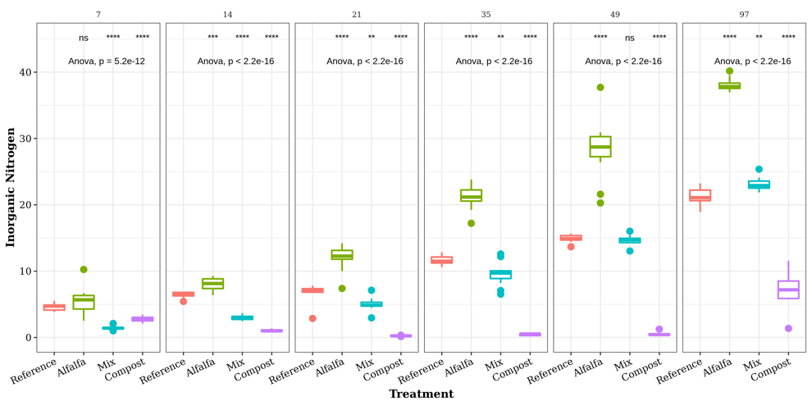

Figure 3 T test comparisons between inorganic N for each day.

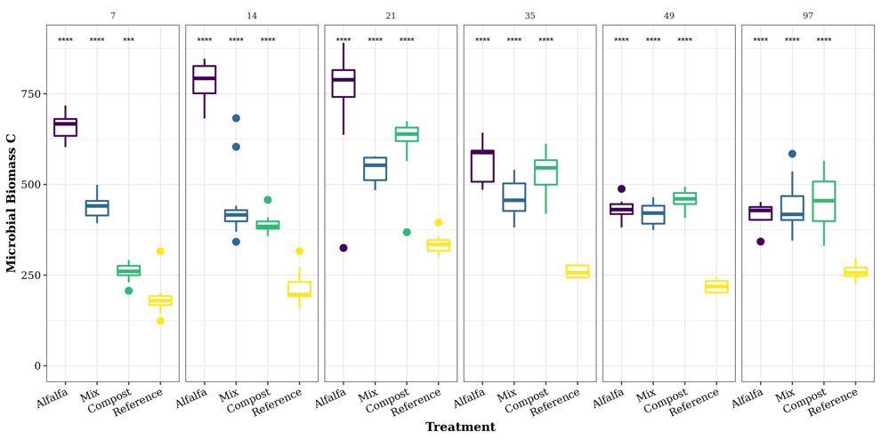

Figure 4 T test comparisons for MBC for each day.

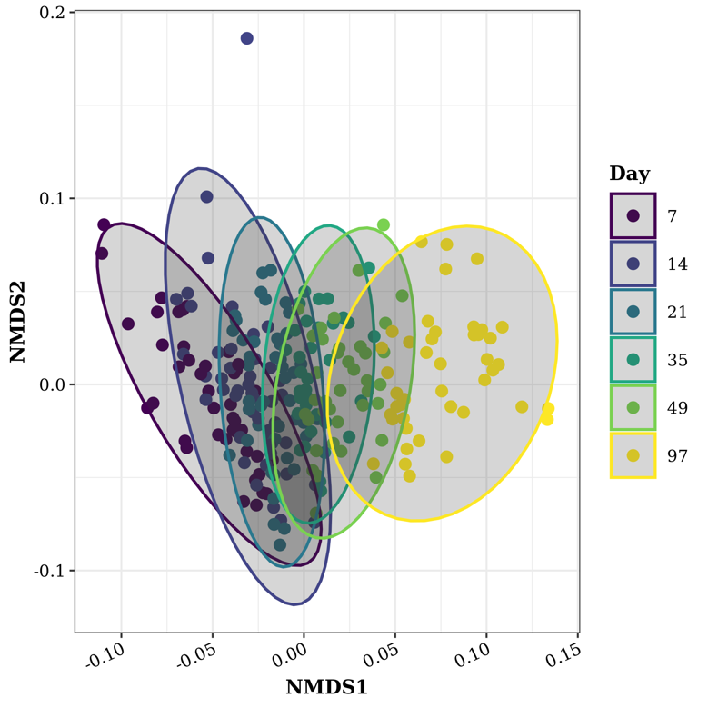

Figure 5 NMDS ordination of the weighted unifrac distance.

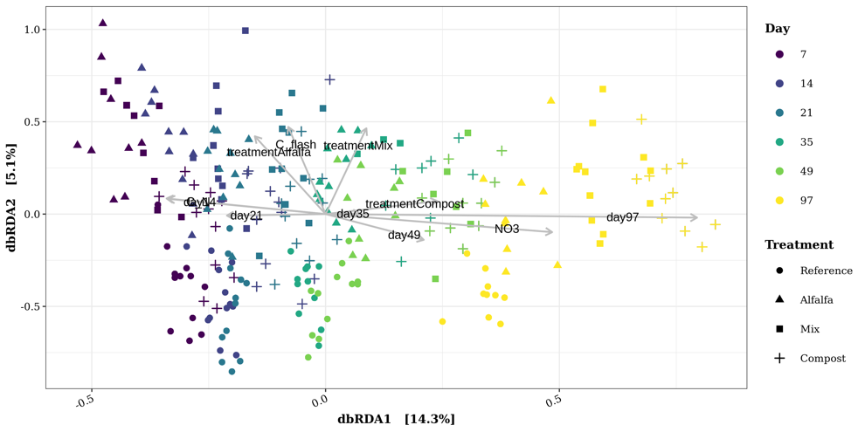

Figure 6 dbRDA ordination with environmental variables fit.

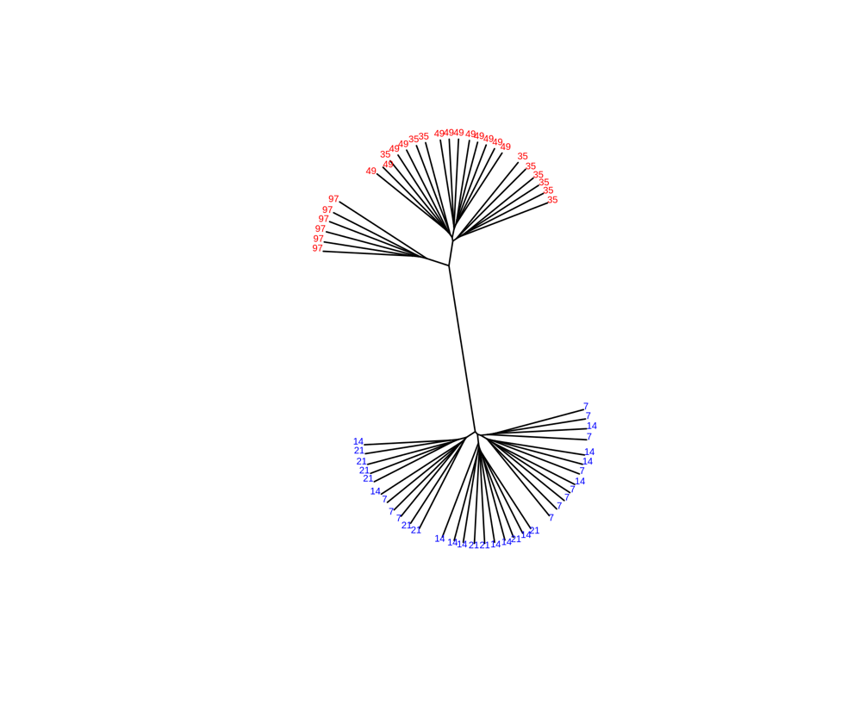

Figure 7

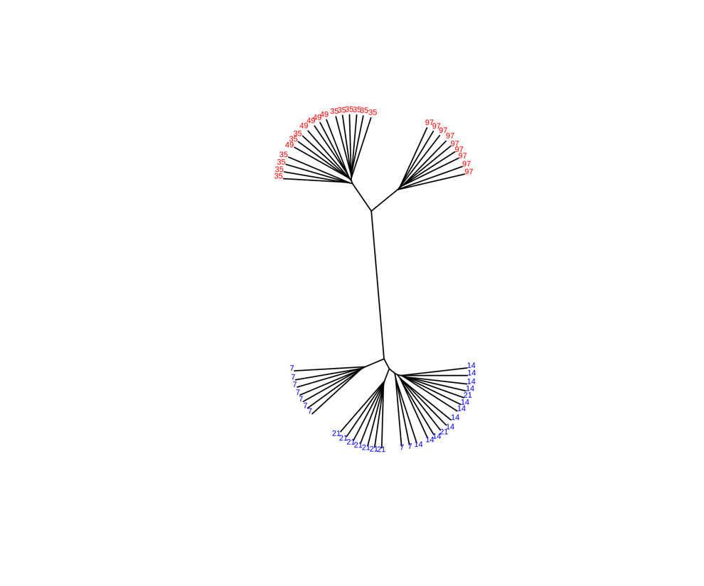

Figure 8

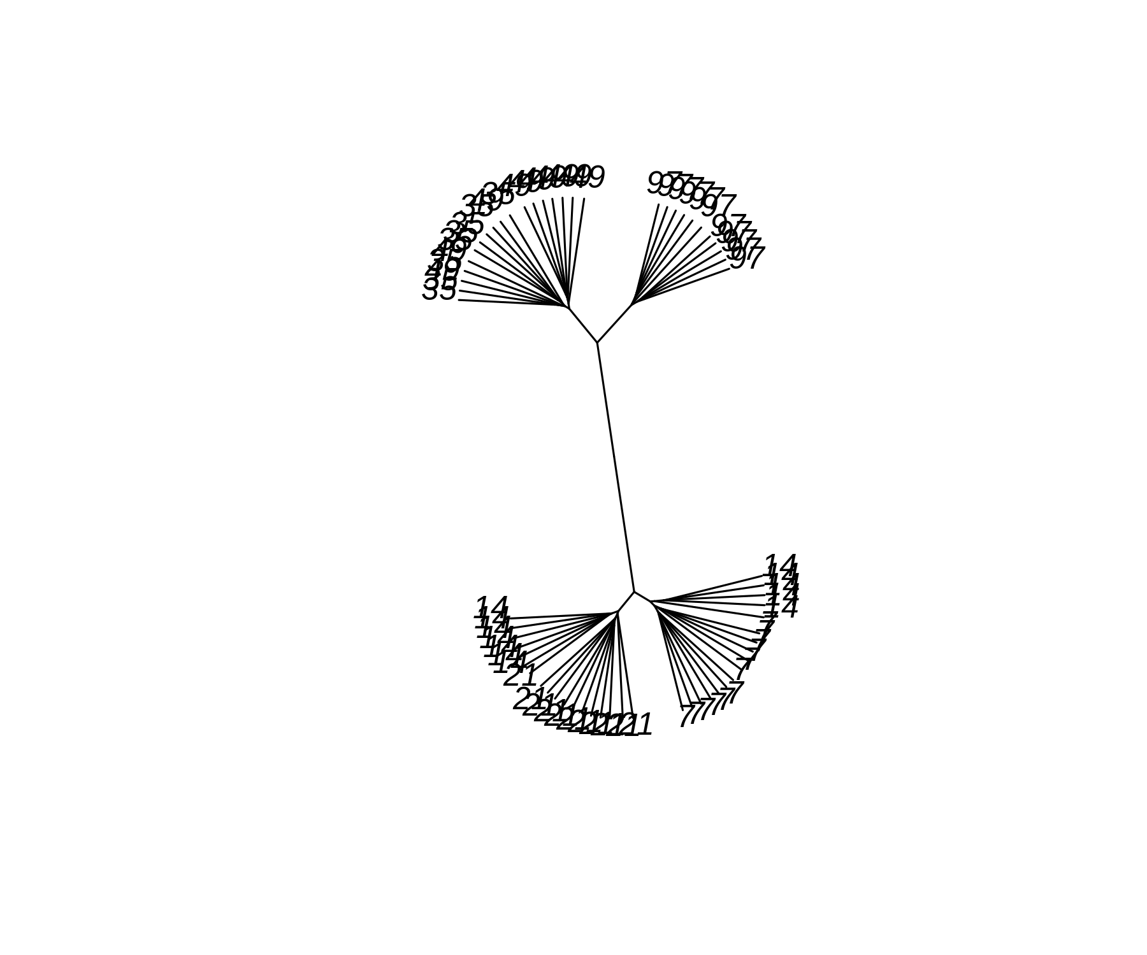

Figure 9

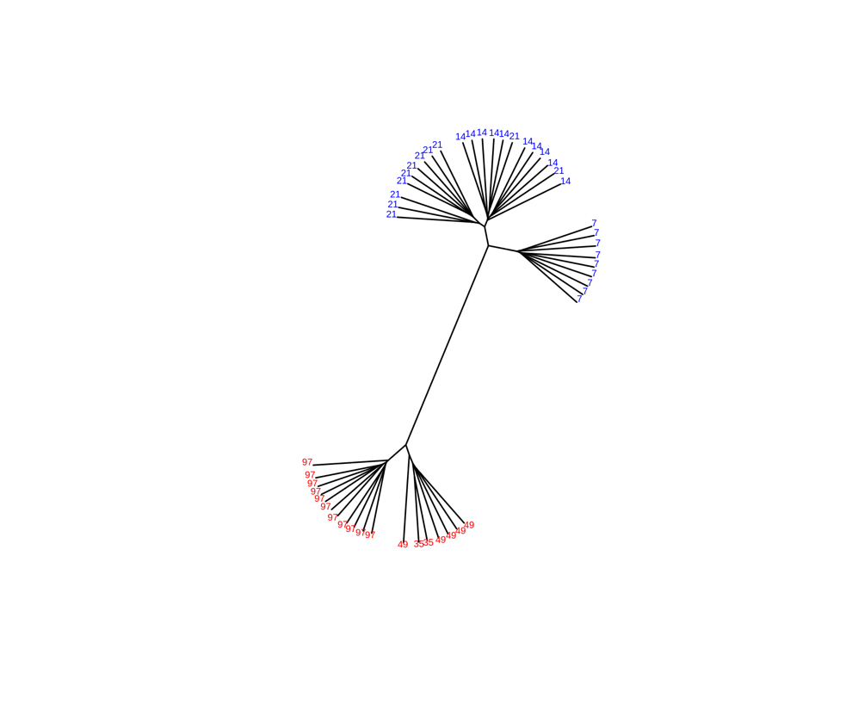

Figure 10

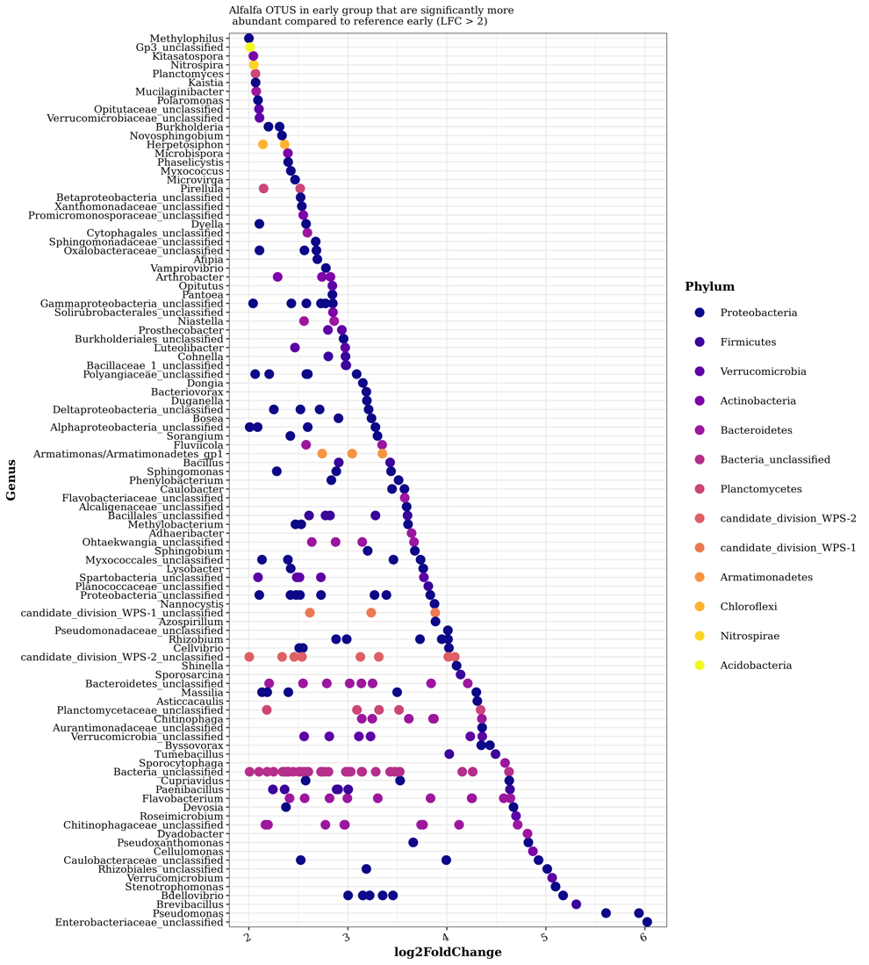

Figure 11

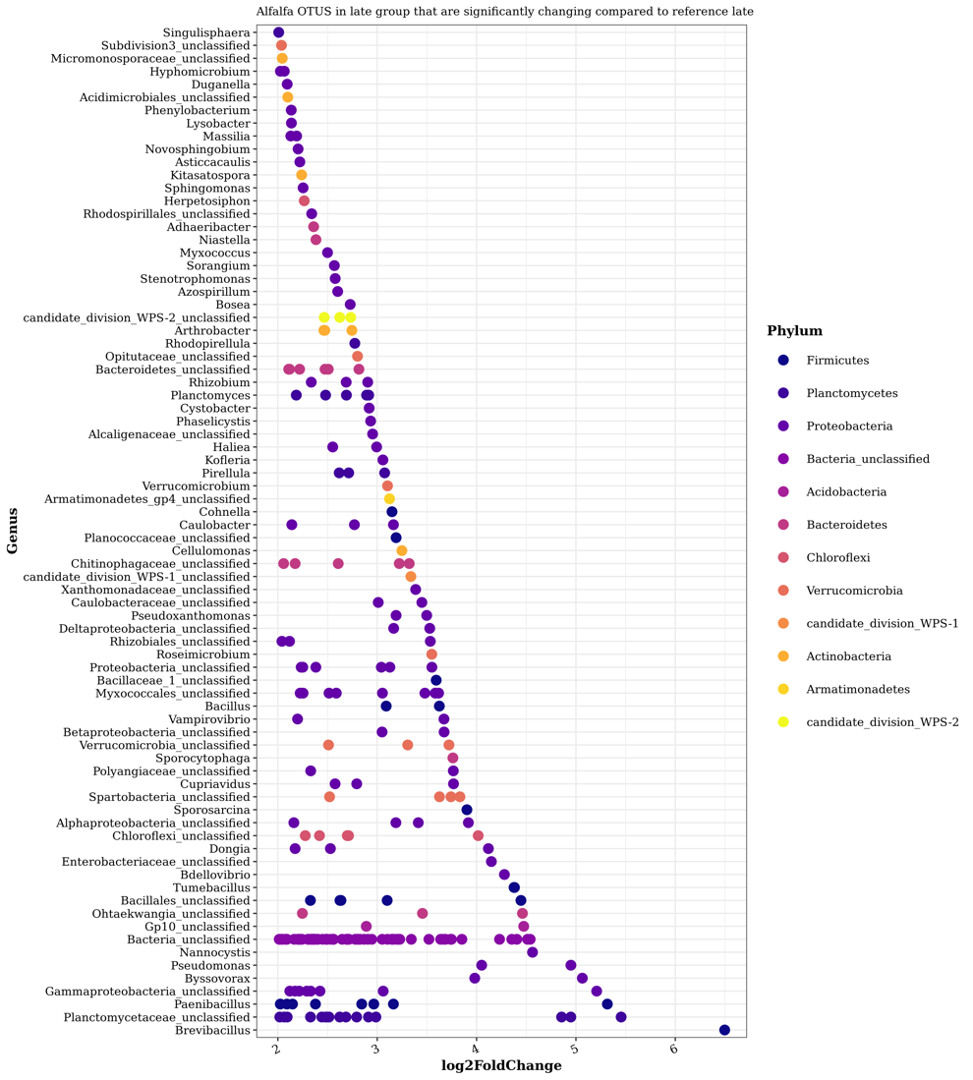

Figure 12

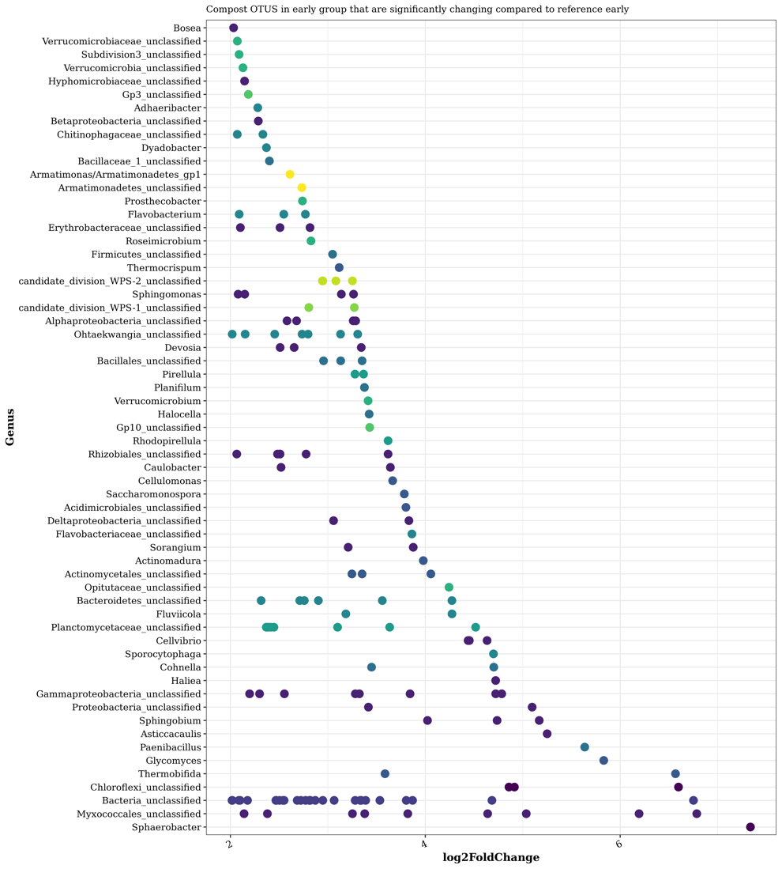

Figure 13

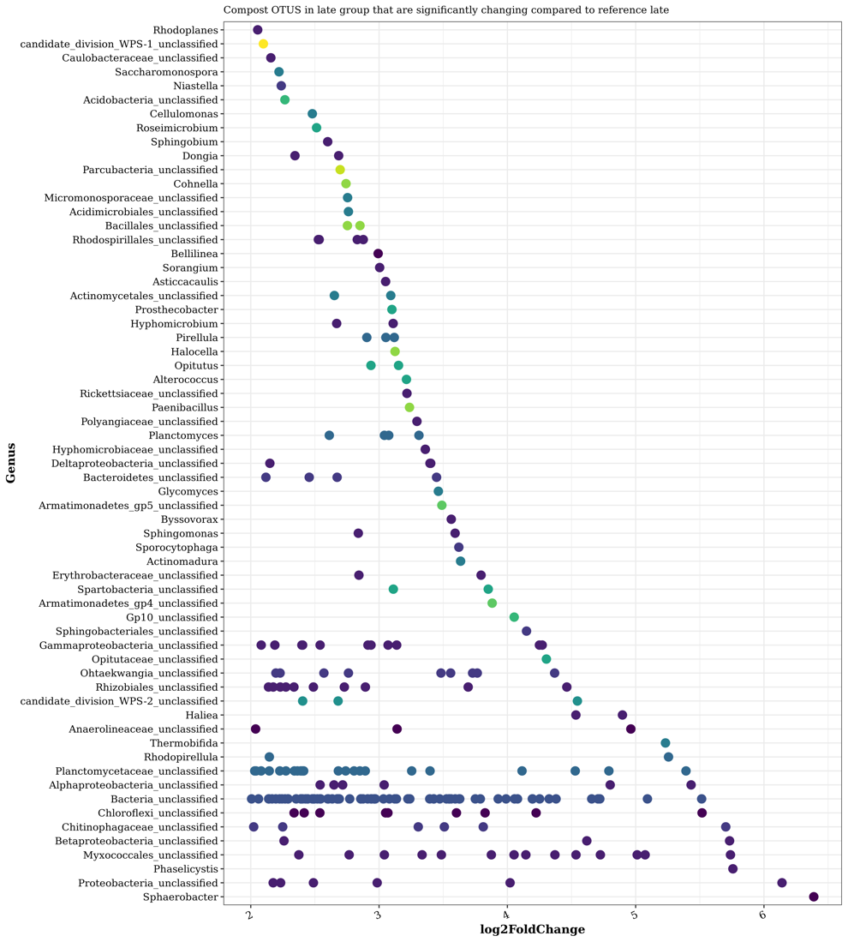

Figure 14

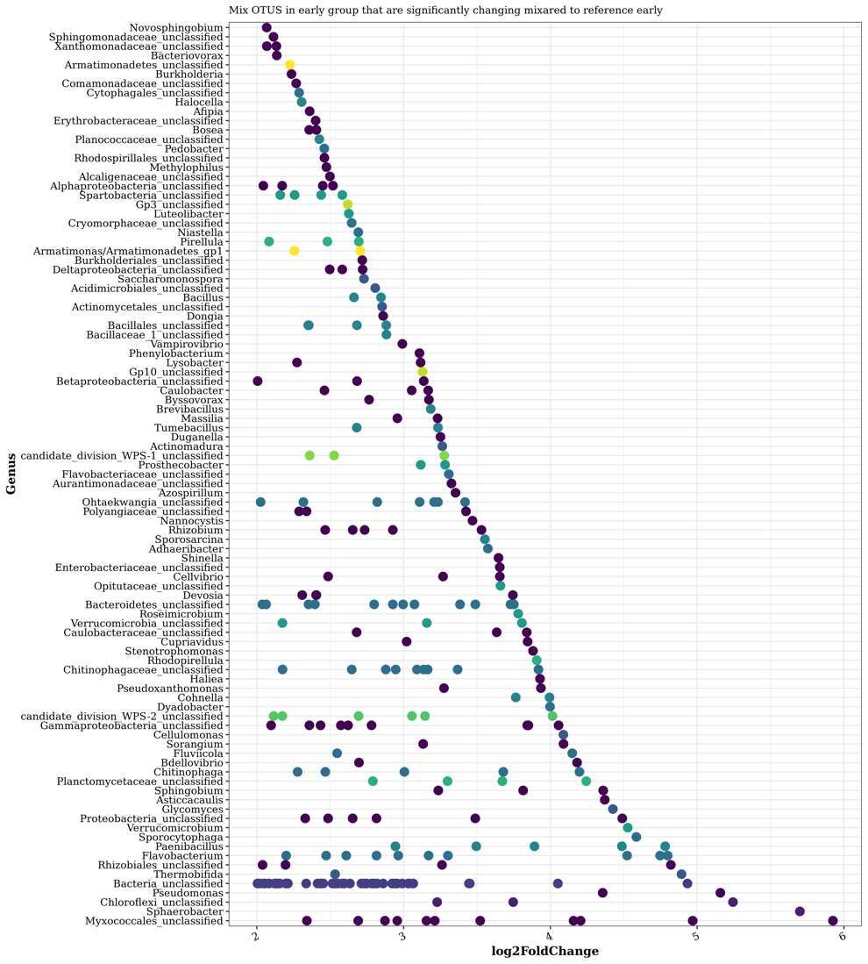

Figure 15

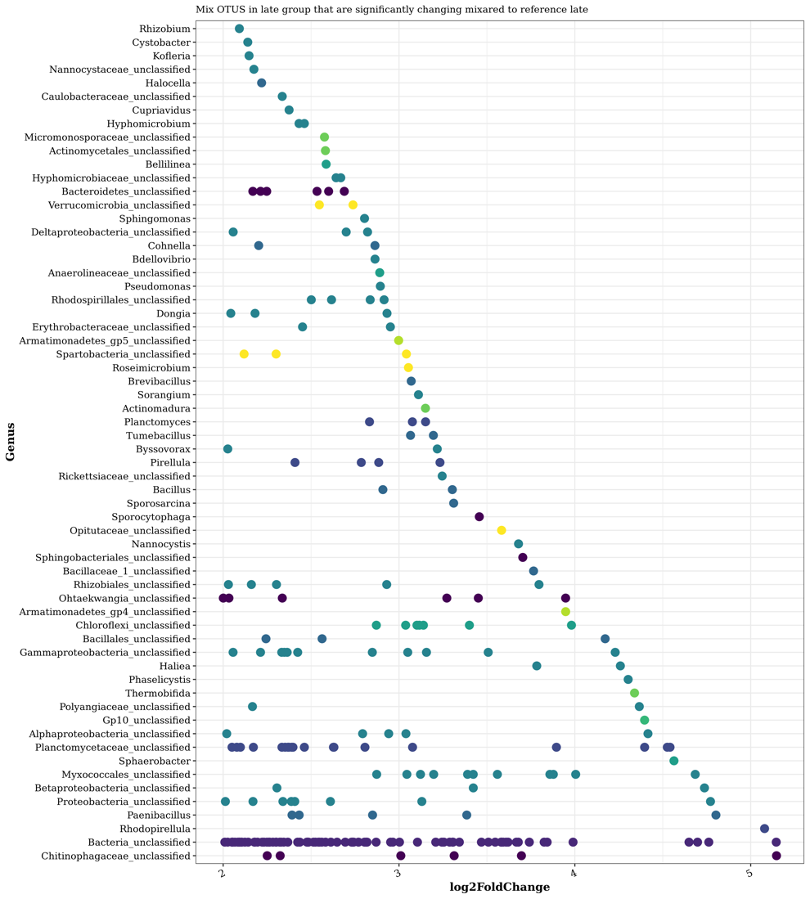

Figure 16

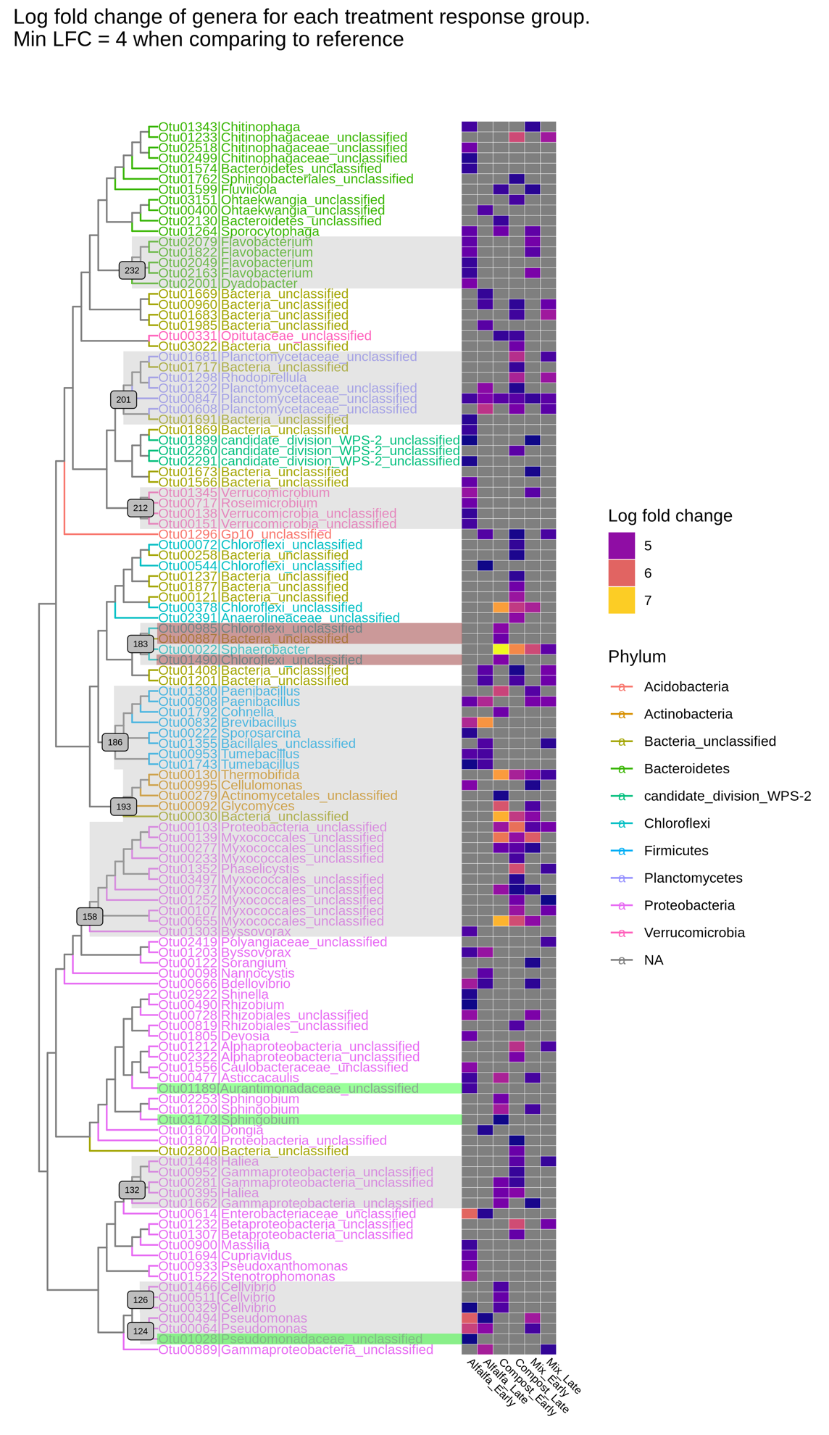

Figure 17

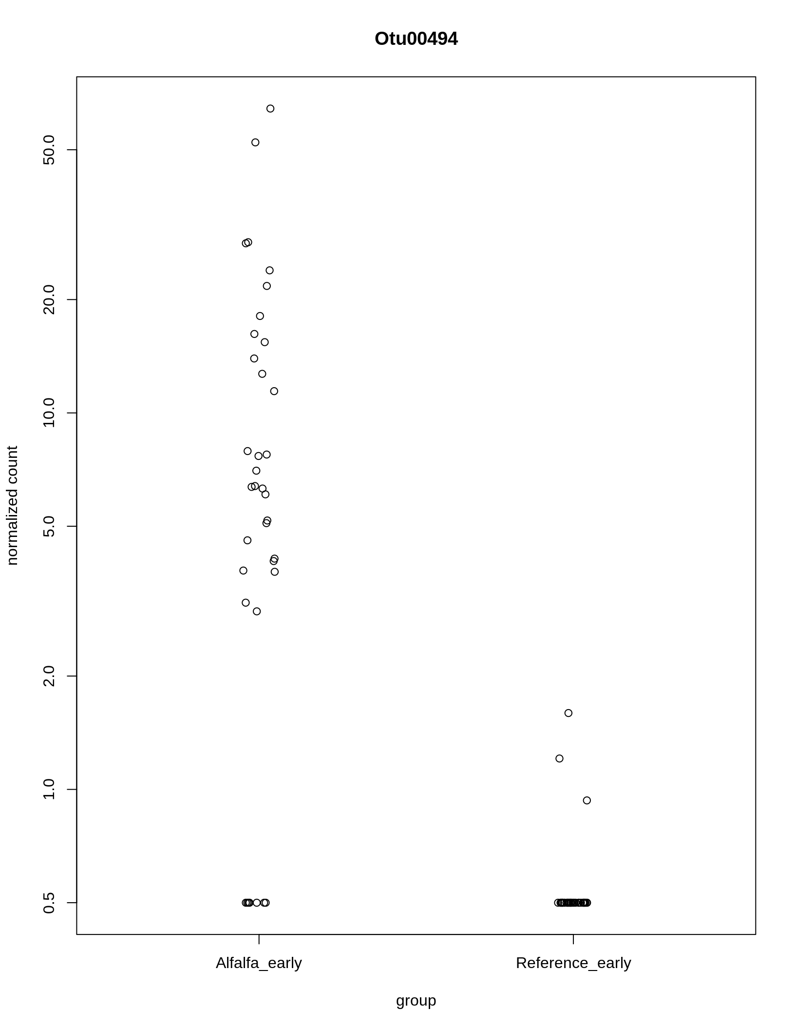

Figure 18

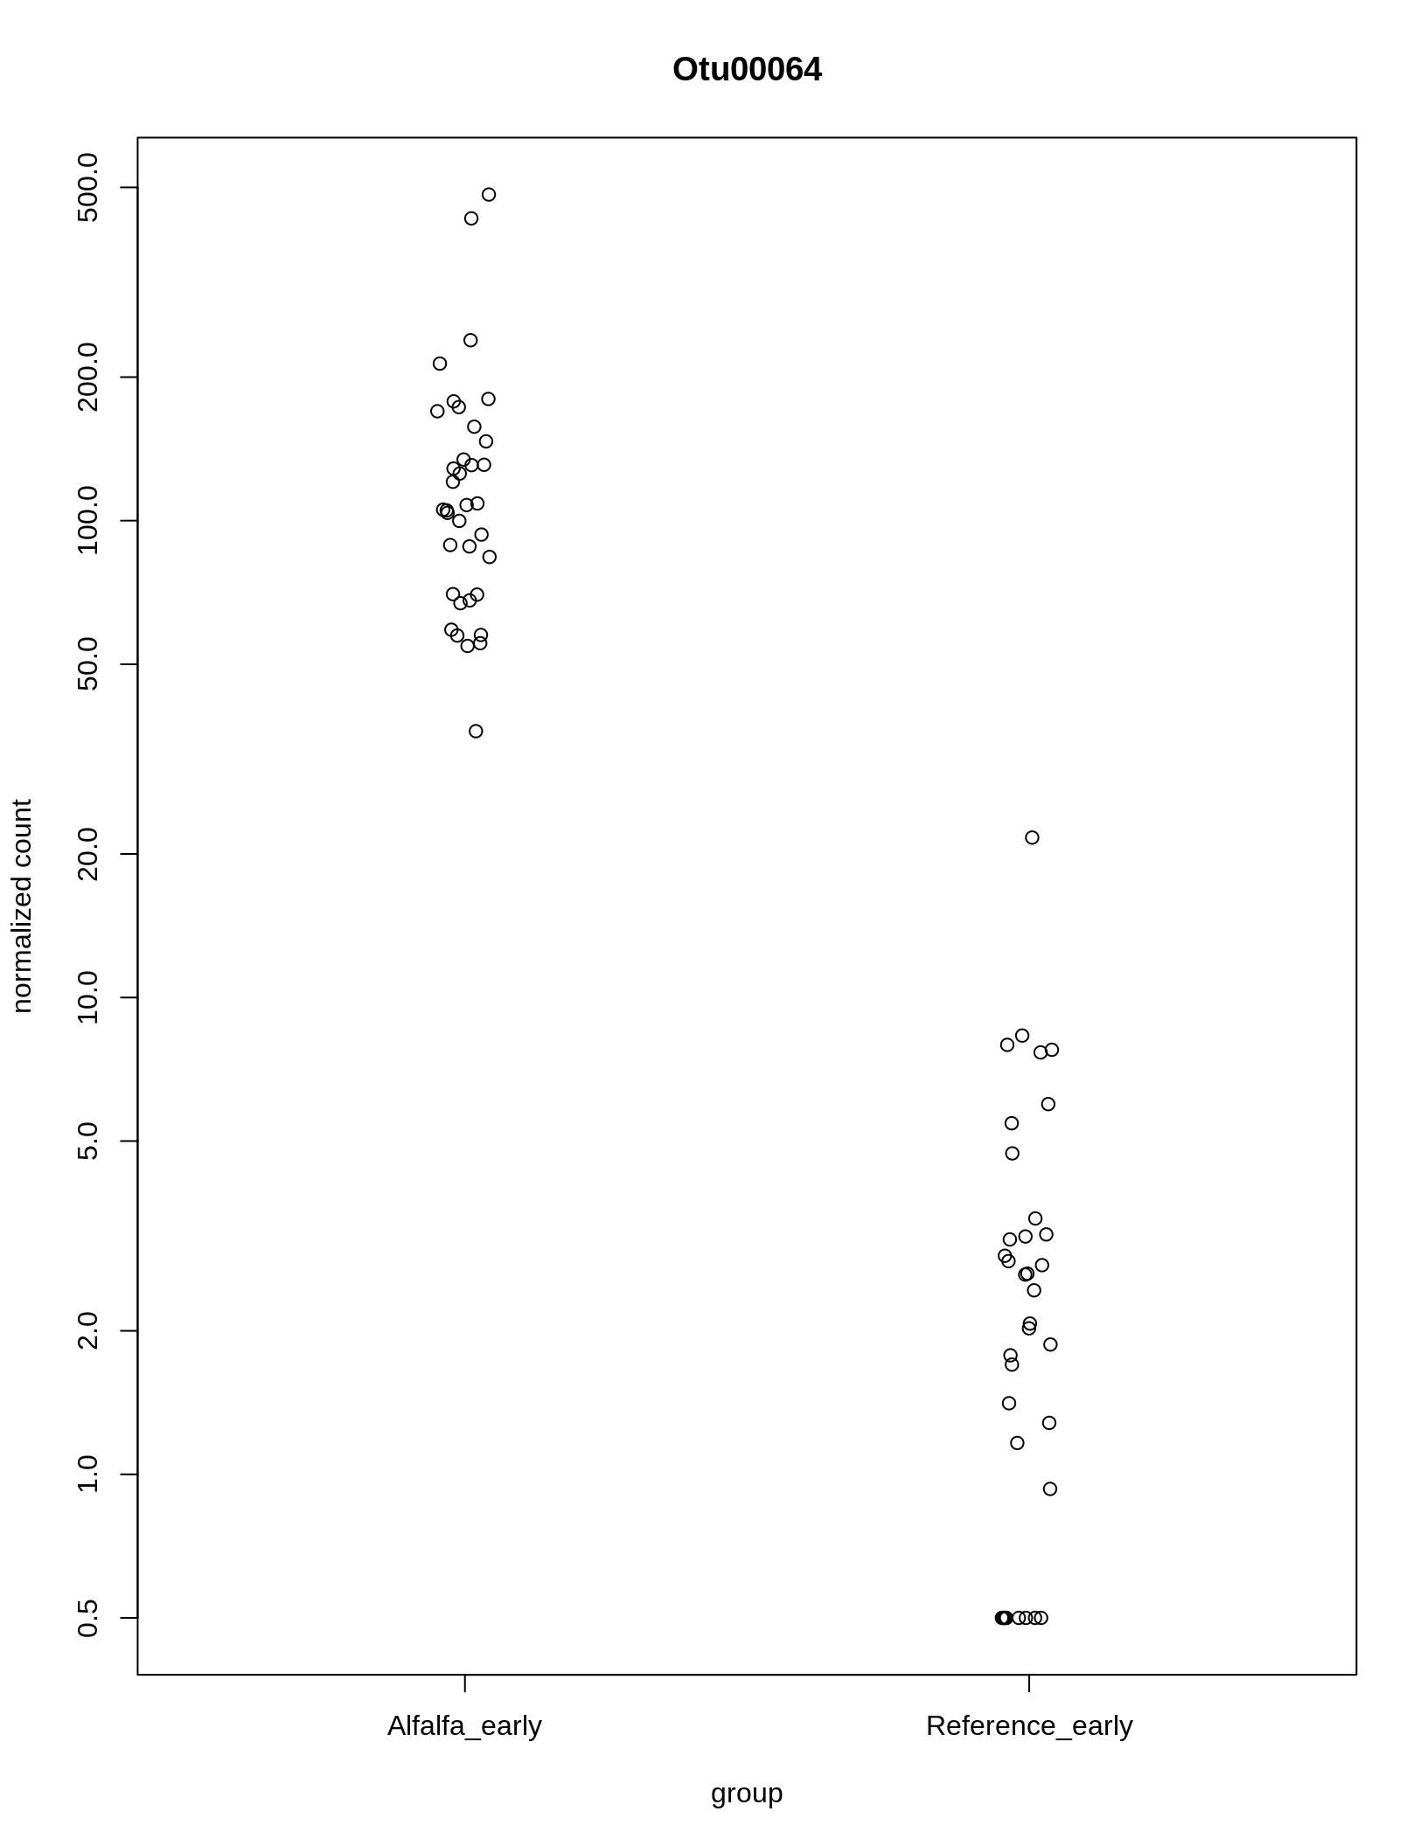

Figure 19

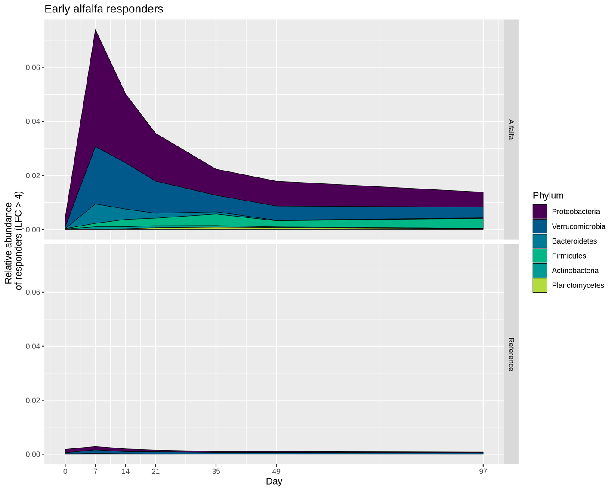

Figure 20

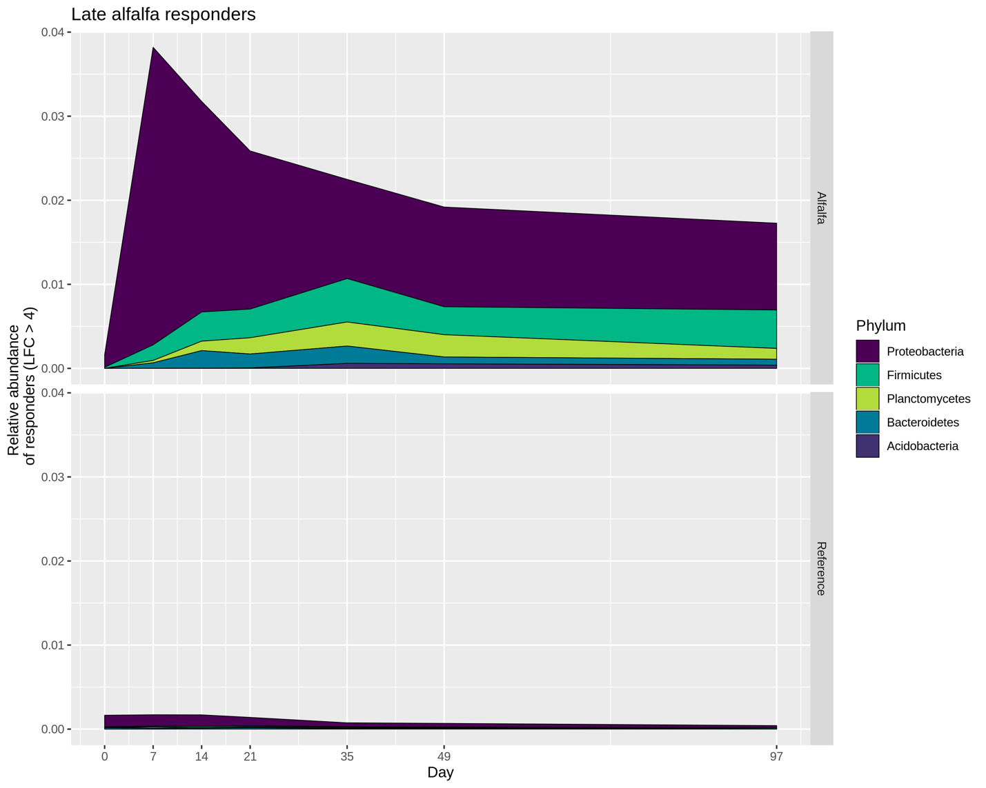

Figure 21

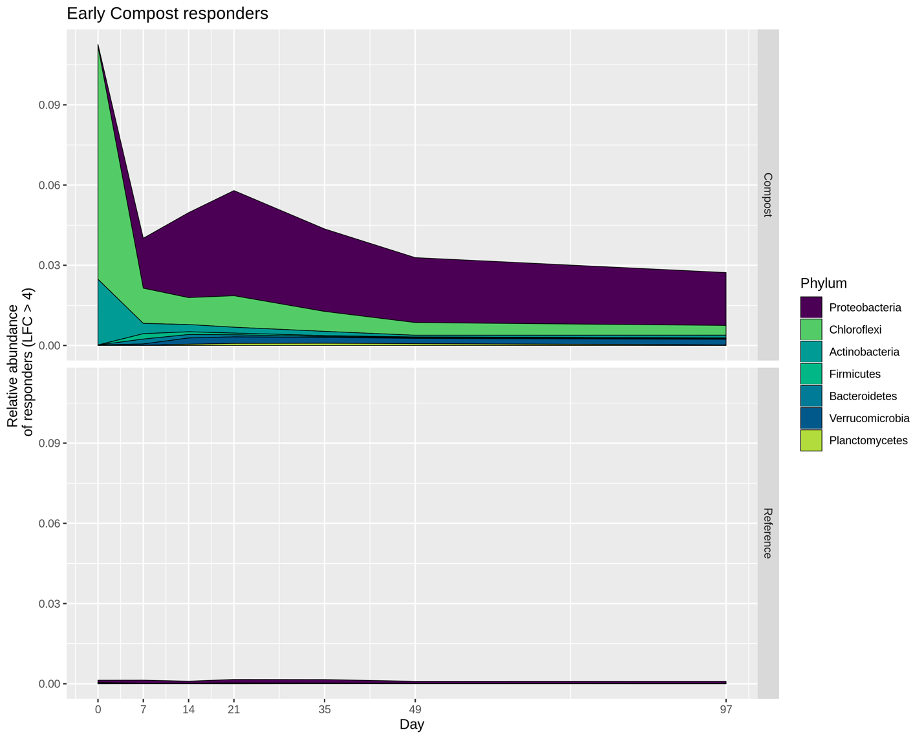

Figure 22

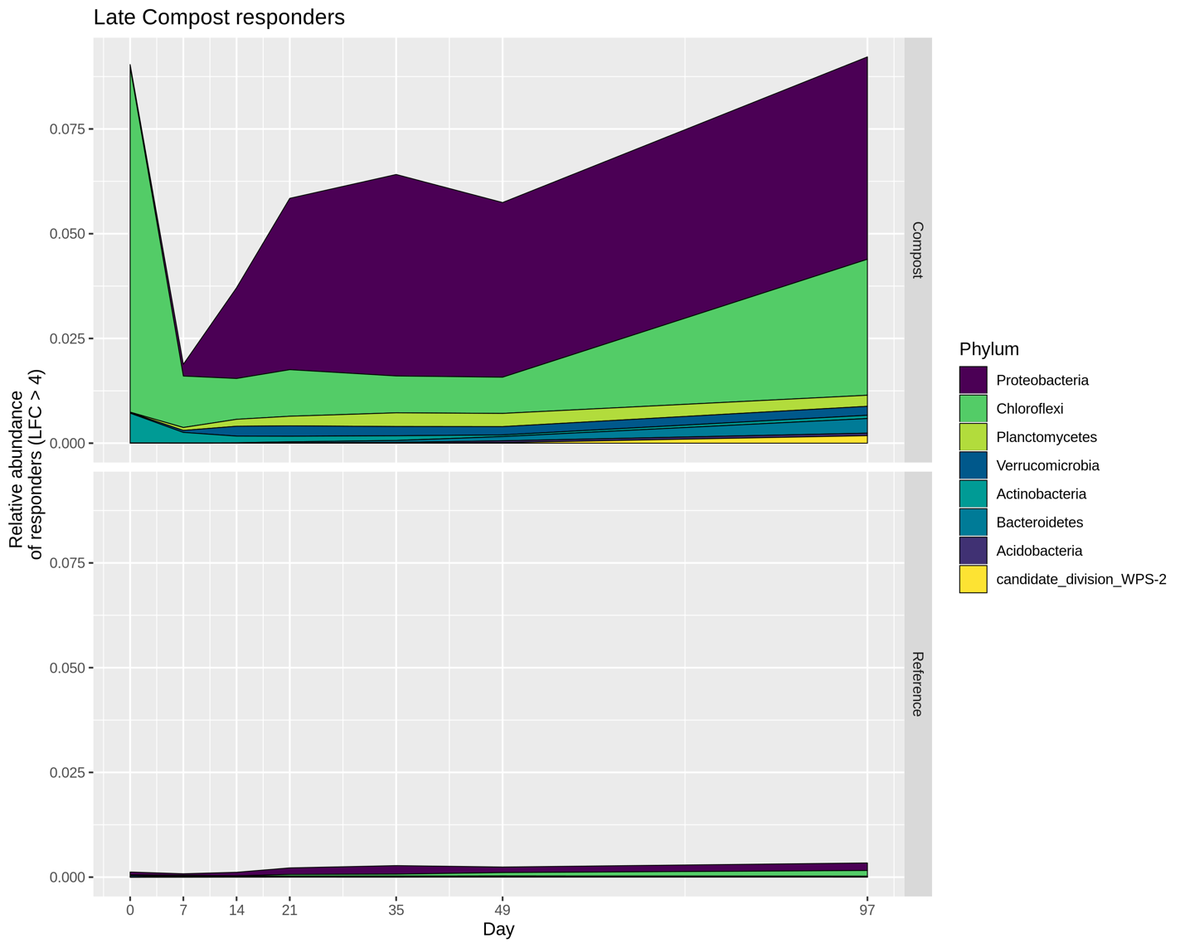

Figure 23

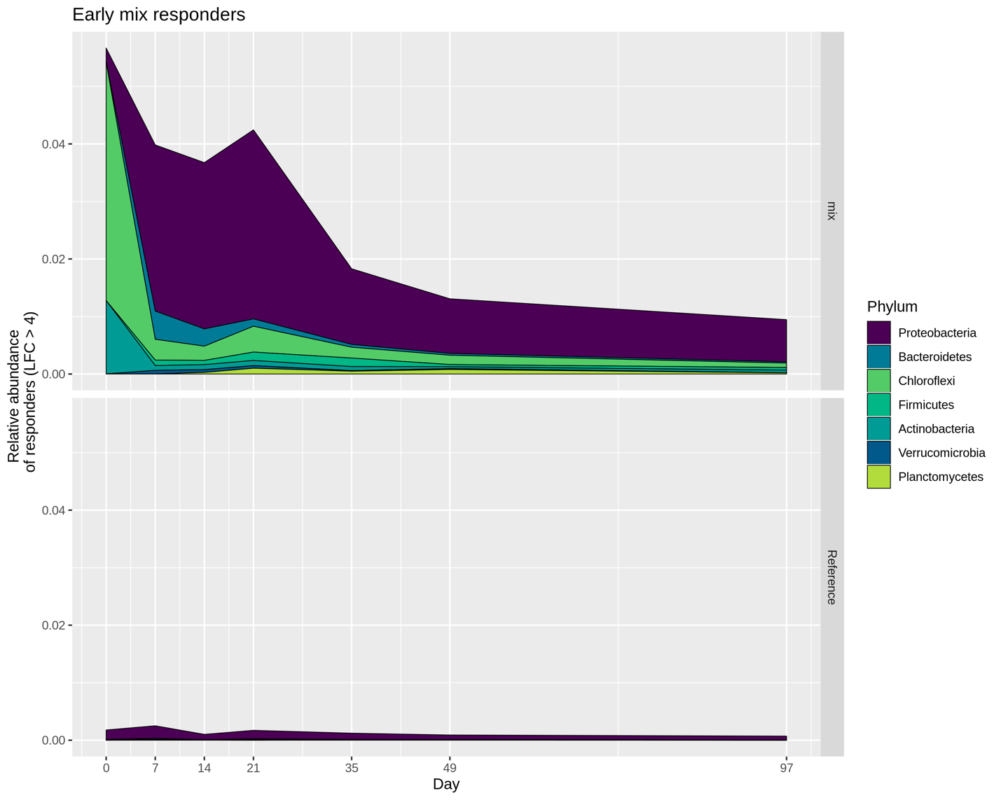

Figure 24

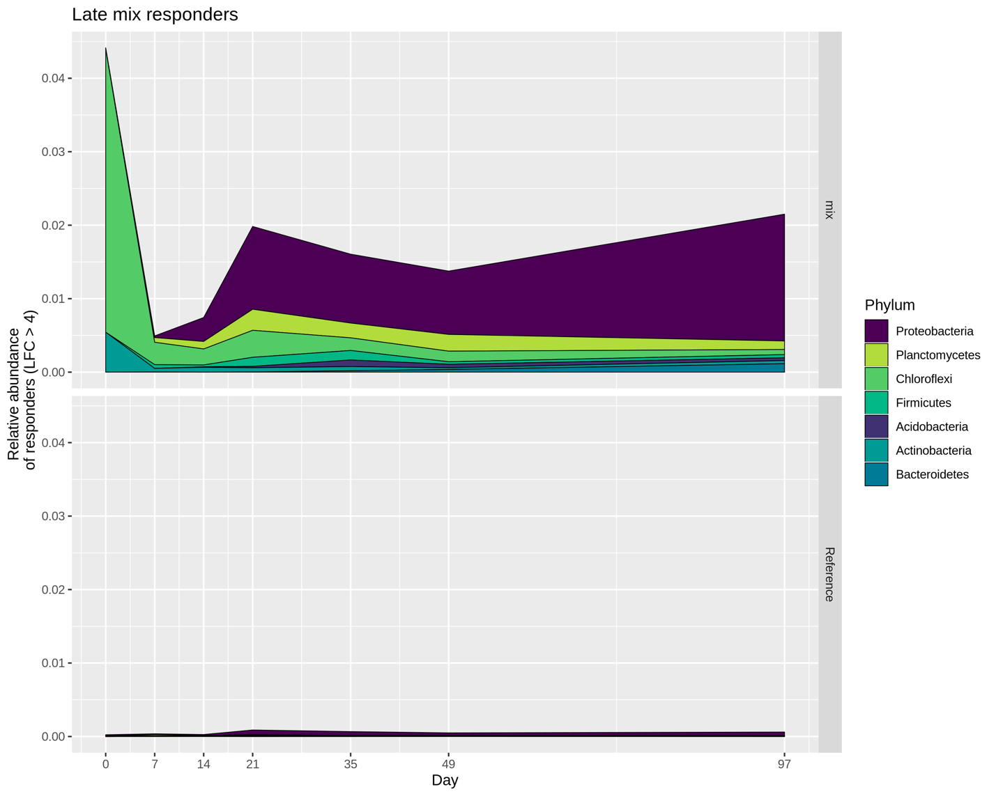

Figure 25

Table 1 Composition of the starting materials.

|  |  |  |  |  |  |  |
| --- | --- | --- | --- | --- | --- | --- |
|  | % C | % N | C:N ratio | NO3 | NH3 | Inorganic N |
| Soil | 2.75 | 0.26 | 10.58 | 1.20 | 2.17 | 3.37 |
| Alfalfa | 41.72 | 2.07 | 20.15 | 5.30 | 20.25 | 25.55 |
| Compost | 33.84 | 1.17 | 28.92 | 1.30 | 12.56 | 13.86 |
| Mixture | 36.24 | 1.44 | 25.16 | 2.54 | 14.89 | 17.43 |

Table 2 Adonis for the incubated samples.

|  |  |  |  |  |  |
| --- | --- | --- | --- | --- | --- |
| formula = distance ~ treatment * day | | | | | |
|  | Df | SumOfSqs | R2 | F | Pr(>F) |
| Treatment | 3 | 0.28 | 0.16 | 26.51 | 0.001 |
| Day | 5 | 0.62 | 0.34 | 34.95 | 0.001 |
| Treatment:Day | 15 | 0.12 | 0.06 | 2.20 | 0.001 |
| Residual | 223 | 0.79 | 0.44 | NA | NA |
| Total | 246 | 1.81 | 1.00 | NA | NA |

Table 3 Alien OTUs and relative abundance.

|  |  |  |  |
| --- | --- | --- | --- |
| Treatment | Total OTUs | Alien OTUs | Alien relative abundance |
| Alfalfa | 17988 | 67 | 0.46% |
| Compost | 19130 | 307 | 1.14% |
| Mix | 21174 | 386 | 0.74% |

Table 4 Variable selection, variation explained.

|  |  |
| --- | --- |
| Variable | Explains (%) |
| Day | 33.05 |
| Treatment | 15.17 |
| Nitrate | 1.31 |
| C:N | 0.51 |
| TOC | 0.31 |
| Others | 0.21 |
| Unexplained | 49.44 |
| Total | 100 |

Table 5 Alfalfa

|  |  |  |  |  |  |
| --- | --- | --- | --- | --- | --- |
| OTU | Phylum | Class | Genus | Early LFC | Late  LFC |
| Otu00064 | Proteobacteria | Gammaproteobacteria | Pseudomonas | 5.61 | 4.95 |
| Otu00494 | Proteobacteria | Gammaproteobacteria | Pseudomonas | 5.94 | 4.05 |
| Otu00614 | Proteobacteria | Gammaproteobacteria | Enterobacteriaceae_unc | 6.02 | 4.15 |
| Otu00666 | Proteobacteria | Deltaproteobacteria | Bdellovibrio | 5.17 | 4.28 |
| Otu00808 | Firmicutes | Bacilli | Paenibacillus | 4.64 | 5.32 |
| Otu00832 | Firmicutes | Bacilli | Brevibacillus | 5.31 | 6.50 |
| Otu00847 | Planctomycetes | Planctomycetia | Planctomycetaceae_unc | 4.34 | 4.86 |
| Otu00953 | Firmicutes | Bacilli | Tumebacillus | 4.49 | 4.38 |
| Otu01203 | Proteobacteria | Deltaproteobacteria | Byssovorax | 4.35 | 5.06 |
| Otu01743 | Firmicutes | Bacilli | Tumebacillus | 4.02 | 4.38 |

Table 6 Compost

|  |  |  |  |  |  |
| --- | --- | --- | --- | --- | --- |
| OTU | Phylum | Class | Genus | Early LFC | Late  LFC |
| Otu00022 | Chloroflexi | Thermomicrobia | Sphaerobacter | 7.34 | 6.39 |
| Otu00030 | Bacteria_unclassified | Bacteria_unclassified | Bacteria_unclassified | 6.75 | 5.51 |
| Otu00103 | Proteobacteria | Proteobacteria_unclassified | Proteobacteria_unclassified | 5.10 | 6.14 |
| Otu00130 | Actinobacteria | Actinobacteria | Thermobifida | 6.57 | 5.23 |
| Otu00139 | Proteobacteria | Deltaproteobacteria | Myxococcales_unclassified | 6.19 | 5.01 |
| Otu00277 | Proteobacteria | Deltaproteobacteria | Myxococcales_unclassified | 4.64 | 4.53 |
| Otu00281 | Proteobacteria | Gammaproteobacteria | Gammaproteobacteria_unc | 4.72 | 4.27 |
| Otu00331 | Verrucomicrobia | Opitutae | Opitutaceae_unclassified | 4.24 | 4.30 |
| Otu00378 | Chloroflexi | Chloroflexi_unclassified | Chloroflexi_unclassified | 6.60 | 5.52 |
| Otu00395 | Proteobacteria | Gammaproteobacteria | Haliea | 4.72 | 4.90 |
| Otu00655 | Proteobacteria | Deltaproteobacteria | Myxococcales_unclassified | 6.79 | 5.74 |
| Otu00737 | Proteobacteria | Deltaproteobacteria | Myxococcales_unclassified | 5.04 | 4.05 |
| Otu00847 | Planctomycetes | Planctomycetia | Planctomycetaceae_unc | 4.52 | 4.53 |

Table 7 Mix

|  |  |  |  |  |  |
| --- | --- | --- | --- | --- | --- |
| OTU | Phylum | Class | Genus | Early LFC | Late LFC |
| Otu00022 | Chloroflexi | Thermomicrobia | Sphaerobacter | 5.70 | 4.56 |
| Otu00103 | Proteobacteria | Proteobacteria_unclassified | Proteobacteria_unclassified | 4.49 | 4.77 |
| Otu00130 | Actinobacteria | Actinobacteria | Thermobifida | 4.89 | 4.34 |
| Otu00808 | Firmicutes | Bacilli | Paenibacillus | 4.78 | 4.80 |
| Otu00847 | Planctomycetes | Planctomycetia | Planctomycetaceae_unclassified | 4.24 | 4.54 |